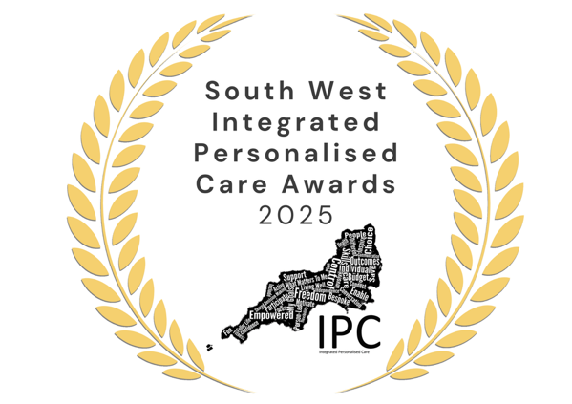

What Matters Award Highly Commended
Mel Meller, Jane Haros, Kimberley Littlemore, and Dr Ros Jennings — for the Dementia Education Training Films for Carers
Tonight, we are delighted to recognise an extraordinary example of personalised care brought to life through creativity, compassion, and true co-production: the Dementia Education Training Films project, created to support and empower carers across Gloucestershire.
This initiative began with a clear purpose — to transform how the workforce understands, listens to, and supports people living with dementia, by embedding What Matters to Me conversations at the heart of everyday care. Led by NHS Gloucestershire’s dementia commissioning team, the project brought together clinicians, creative partners, academics, carers, and people with lived experience to co-produce a series of ten deeply human, highly impactful training films.
What sets this work apart is its authenticity. Through sensitive engagement, life-story conversations, robust ethical processes, and unobtrusive filming within real care environments, the team captured genuine moments of connection, challenge, and compassion. These lived interactions — enriched by expert commentary from dementia specialists and an expert-by-experience — create training resources that feel real, relatable, and emotionally powerful.
The impact is significant. For individuals and carers, the films illuminate what personalised dementia care truly means: dignity, curiosity, empathy, and a deep understanding of each person’s identity, history, and hopes. For the system, they offer a scalable, high-quality training tool that strengthens staff confidence and competence — improving communication, assessment, and holistic support across health and social care.
Staff describe the project as profoundly meaningful, offering rare insight into the lived experience of dementia and transforming the way they approach conversations and care planning. The team hopes this model will shape national training, supported by wider investment in “train-the-trainer” programmes and development.
This project stands as a powerful example of personalised care at its best — co-produced, creative, evidence-based, and rooted in humanity.


